|  |
| --- |
|  |
| Capstone Event Document |

**WingS**

Report #2 – Screen Design

|  |  |  |
| --- | --- | --- |
| **WingS** | | |
| **Group Members** | Đào Trọng Nghĩa | SE03220 |
| Lê Hồng Nhiên | SE03377 |
| Tạ Ngọc Duy | SE03267 |
| Đỗ Văn Tuấn | SE03297 |
| Hoàng Tuấn Anh | SE03108 |
| **Supervisor** | Mr. Nguyễn Văn Sang | |
| **Event code** | WS | |

**- Hanoi, 09/2016 -**

# SIGNATURE PAGE

AUTHOR: Tạ Ngọc Duy 06/09/2016

Team member

REVIEWERS: Đào Trọng Nghĩa 07/09/2016

Event manager

APPROVAL: Nguyễn Văn Sang --/--/--16

Supervisor

Record of change

*A - Added M - Modified D – Deleted

|  |  |  |  |  |  |
| --- | --- | --- | --- | --- | --- |
| Effective Date | Changed Item | A,M,D | Change Description | Reason for Change | Rev. Number |
| 26/Sep/2015 | Create Screen Design | A | First version | Create Screen Design | 1.0 |
|  |  |  |  |  |  |
|  |  |  |  |  |  |
|  |  |  |  |  |  |
|  |  |  |  |  |  |
|  |  |  |  |  |  |
|  |  |  |  |  |  |
|  |  |  |  |  |  |
|  |  |  |  |  |  |
|  |  |  |  |  |  |
|  |  |  |  |  |  |
|  |  |  |  |  |  |
|  |  |  |  |  |  |
|  |  |  |  |  |  |
|  |  |  |  |  |  |
|  |  |  |  |  |  |
|  |  |  |  |  |  |
|  |  |  |  |  |  |
|  |  |  |  |  |  |
|  |  |  |  |  |  |
|  |  |  |  |  |  |
|  |  |  |  |  |  |
|  |  |  |  |  |  |

Table of Contents

SIGNATURE PAGE 1

Introduction 3

1.1 Purpose 3

1.2 Definitions, Acronyms and Abbreviations 3

1.3 Overview 3

2 Screen flow 4

2.1 Register 4

2.2 Login 5

2.3 Search Event 6

2.4 Discover 7

2.5 Create Event 9

2.6 Edit Event 11

2.7 Statistic 11

2.8 Event detail 11

2.9 Back Event 11

2.10 Message 11

2.11 Event management 11

2.12 Account management 11

2.13 ADMIN 11

# Introduction

## Purpose

To ensure consistency and simplicity in detailed design across all displays within a product interface, as well as across other products used by the same users. Definitions, acronyms, abbreviations, references and overview of WS website.

## Definitions, Acronyms and Abbreviations

|  |  |  |
| --- | --- | --- |
| Abbreviations | Description | Comment |
| WS | WingS |  |
| Q&A | Question and Answer |  |

1. Definitions, Acronyms and Abbreviations

## Overview

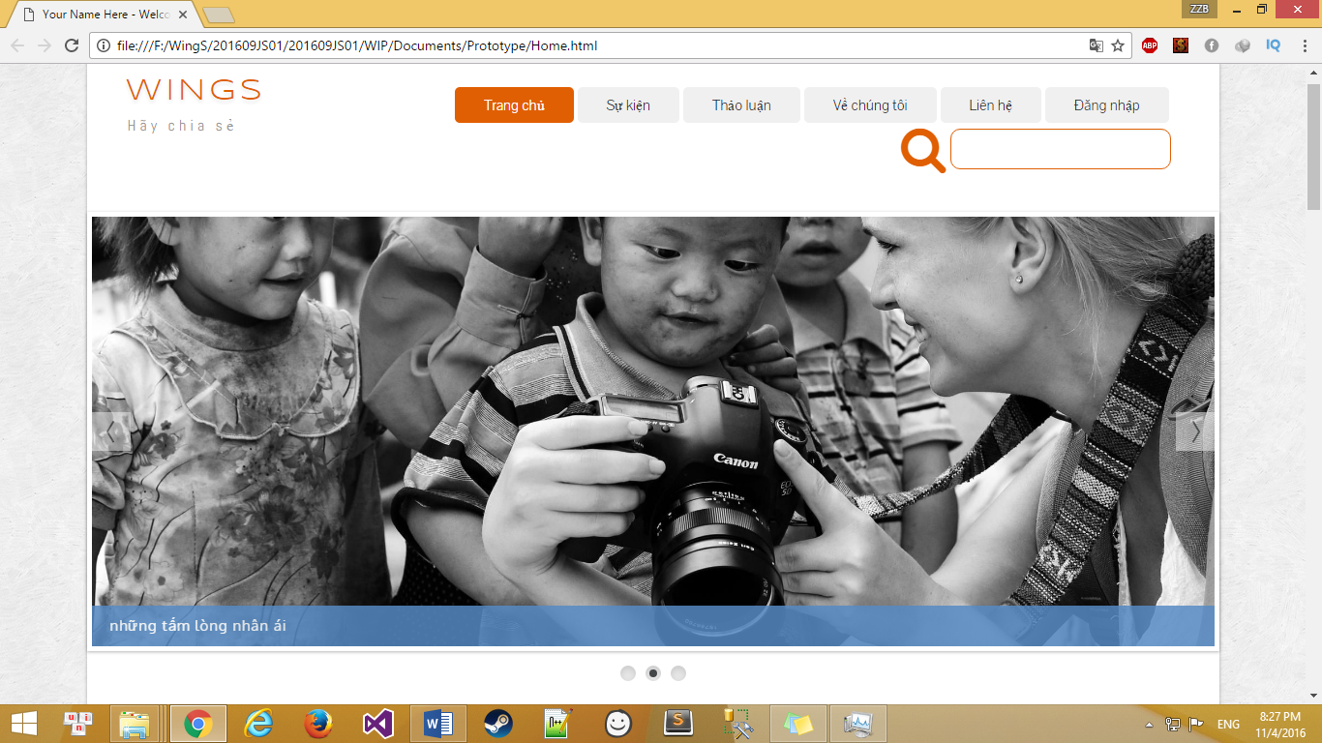

# Screen flow

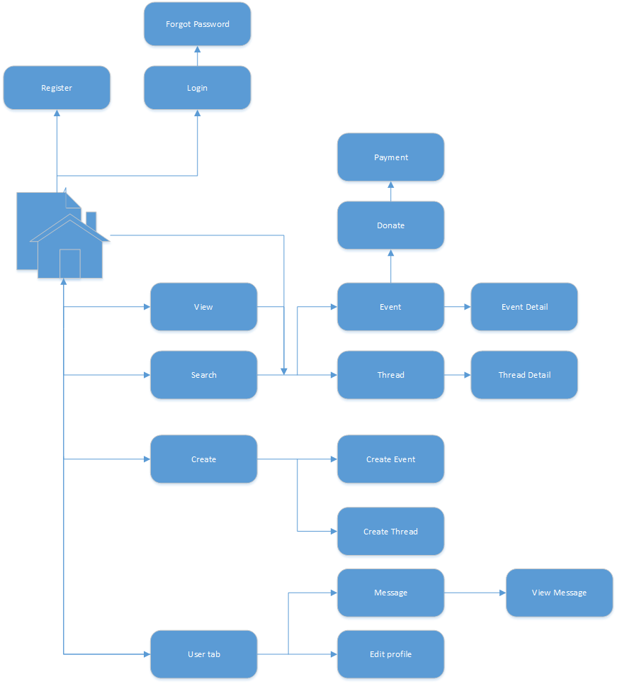

1. Client screen flow

## Register

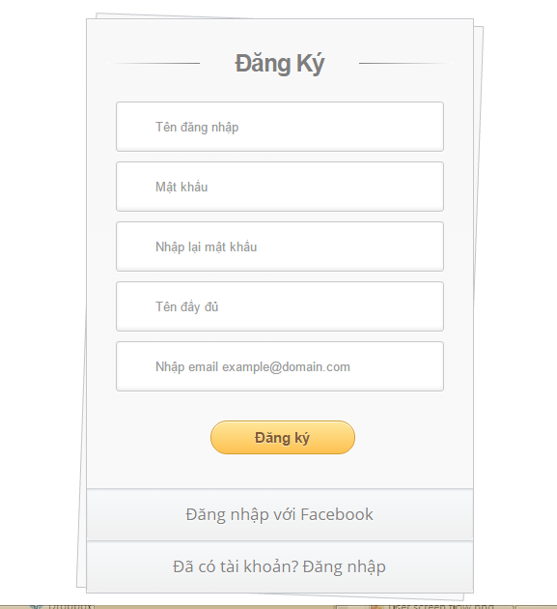

1. R**egister screen**

|  |  |  |  |  |  |  |  |
| --- | --- | --- | --- | --- | --- | --- | --- |
| No | Field name | Field name in Vietnamese | Type | Require | Mandatory | Max-Length | Description |
|  | Register | Đăng ký | Label |  | Y |  | Display register form |
|  | AccountName | Tên hiển thị | Text box | Type | Y | 8-20 | Name of user |
|  | Username | Tên tài khoản | Text box | Type | Y | 8-20 | Username of user |
|  | Password | Mật khẩu | Text box | Type | Y | 8-50 | Password of user |
|  | Confirm Password | Nhập lại mật khẩu | Text box | Type | Y |  | User retype password |
|  | Email | Email | Textbox | Type | Y |  | Email of user |
|  | Sign up | Đăng ký | Button | Click | Y |  | User register a new account |
|  | Login now | Đăng nhập ngay | Hyperlink | Click | Y |  | Login when user have an account |

1. R**egister** screen

## Login

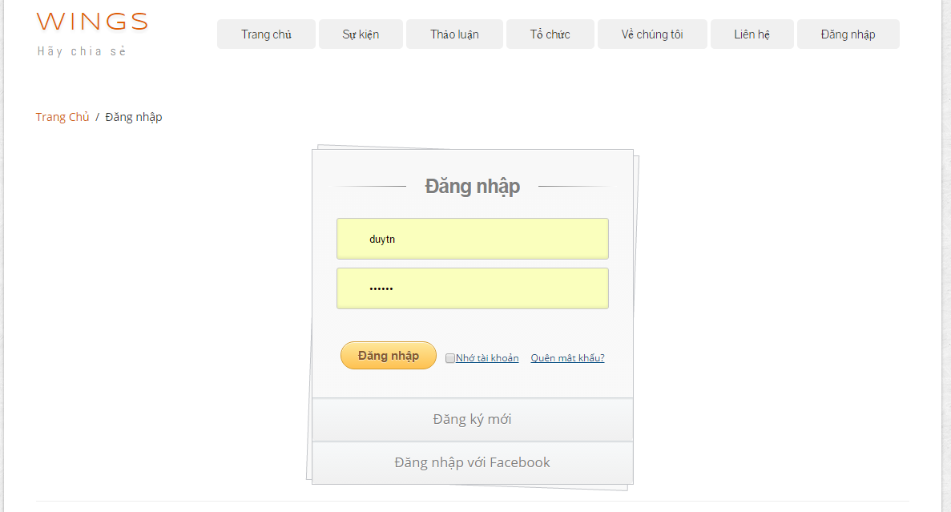

1. Login **screen**

|  |  |  |  |  |  |  |  |
| --- | --- | --- | --- | --- | --- | --- | --- |
| No | Field name | Field name in Vietnamese | Type | Require | Mandatory | Max-Length | Description |
|  | Username | Tên đăng nhập | Text box | Type | Y |  | Username of registered user |
|  | Password | Mật khẩu | Text box | Type | Y |  | Password of registered user |
|  | Remember Me | Lưu đăng nhập | Check box | Click | Y |  | Save login information |
|  | Login | Đăng nhập | Button | Click | Y |  | Login |
|  | Forgot Password | Quên mật khẩu | Hyperlink | Click | Y |  | Resend password to user |
|  | Register now | Đăng ký | Hyperlink | Click | Y |  | Register when user have not an account |
|  | Login with Facebook | Đăng nhập qua Facebook | Button | Click | Y |  | Login with Facebook |

1. Loginscreen

## Searching

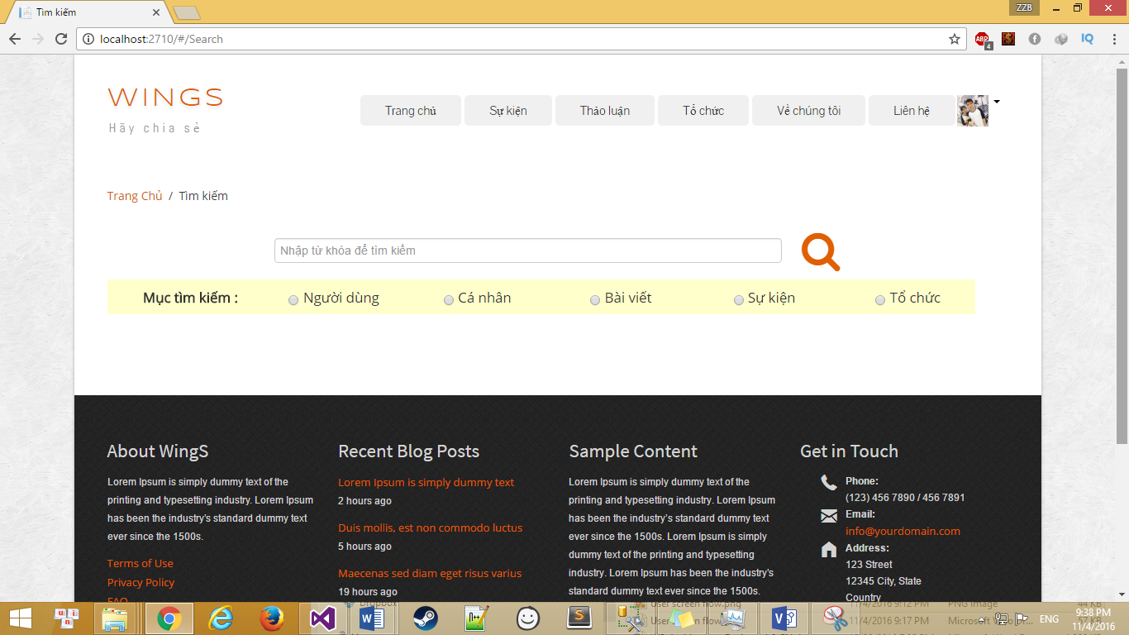

1. Searching screen design

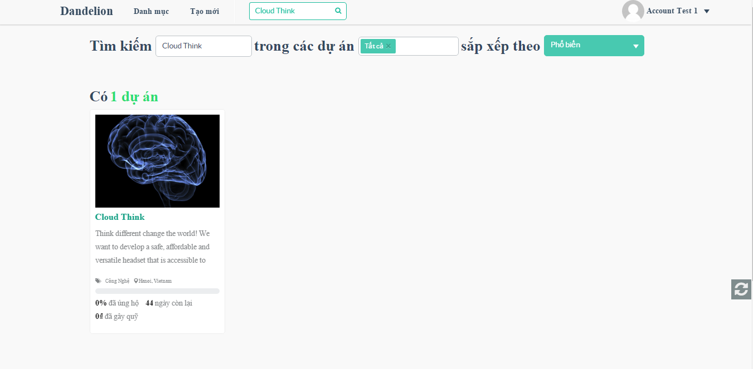

1. Search Event result screen design

|  |  |  |  |  |  |  |  |
| --- | --- | --- | --- | --- | --- | --- | --- |
| No | Field name | Field name in Vietnamese | Type | Require | Mandatory | Max-Length | Description |
| 1 | Search box | Ô tìm kiếm | Text |  | Y |  | Display text |
| 2 | Search icon |  | Button | Click | Y |  | Search Event |
| 2 | Search result box | Tìm kiếm | Text |  | Y |  | Display search text |
| 3 | Event category | Người dùng | Radio button | Click | Y |  | Filter by category of Events |
| 4 | P | Cá nhân | Radio button | Click | Y |  | Filter by status of Events |
| 5 | Thread | Bài viết | Radio button | Click | Y |  | Filter by status of Events |
| 5 | Organization | Tổ chức | Radio button | Click | Y |  | Filter by status of Events |
| 6 | List result | Kết quả | List |  |  |  | Display list result |

1. Searchscreen

## View

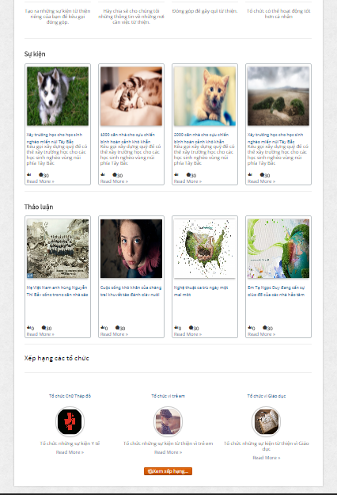

1. Home viewscreen

|  |  |  |  |  |  |  |  |
| --- | --- | --- | --- | --- | --- | --- | --- |
| No | Field name | Field name in Vietnamese | Type | Require | Mandatory | Max-Length | Description |
| 1 | Event | Event | Label |  | Y |  | Label display “Event” |
| 2 | List event | Danh sách các Event | List |  | Y |  | Display list of event |
| 3 | Thread | Thảo luận | Label |  | Y |  | Label display “Thảo luận” |
| 5 | List thread | Danh sách các bài thảo luận | List |  | Y |  | Display list of thread |
| 6 | Organization ranking | Xếp hạng các tổ chức | Label |  | Y |  | Label display “Xếp hạng các tổ chức” |
| 7 | List highest ranking | Các tổ chức xếp hạng cao nhất | List |  | Y |  | Display 3 of highest rank organization |
| 8 | View ranking | Xem xếp hạng | Button |  | Y |  | Button display “Xem xếp hạng” |

1. Home viewscreen

## Create event

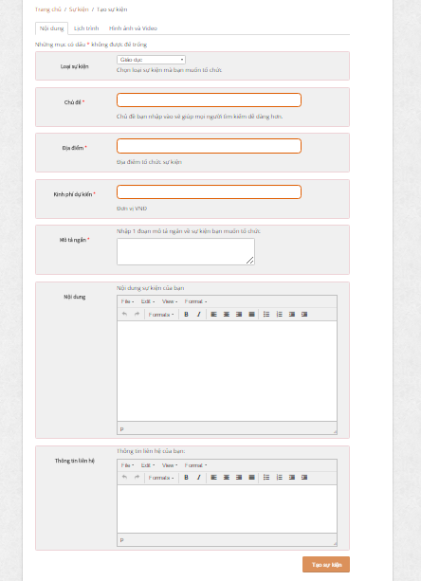

1. Create event screen (Content)

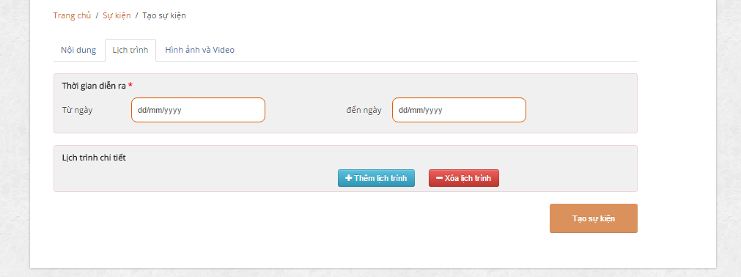

1. Create event screen (Schedule)

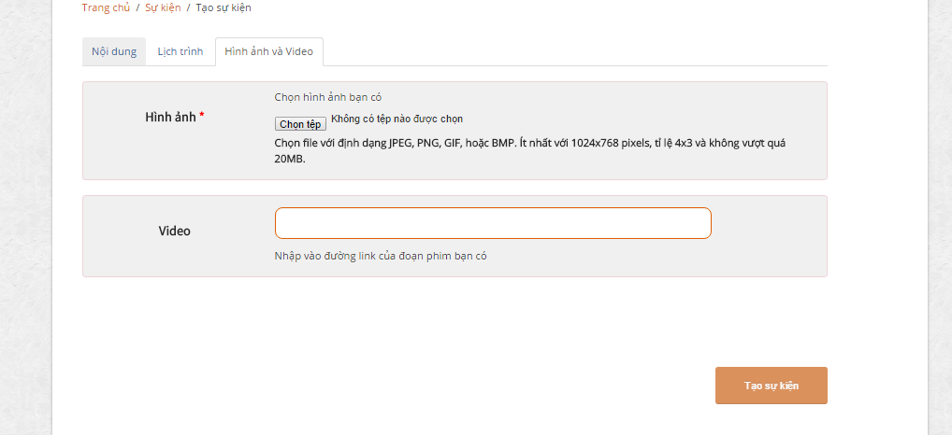

1. Create event screen (Pictures and videos)

|  |  |  |  |  |  |  |  |
| --- | --- | --- | --- | --- | --- | --- | --- |
| No | Field name | Field name in Vietnamese | Type | Require | Mandatory | Max-Length | Description |
| 1 | Content | Nội dung | Tab | Click | Y |  | Content of event |
| 2 | Warning | Những mục có dấu * không được để trống |  |  |  |  |  |
| 3 | Event category | Loại Event | DropdownList | Click | Y |  | Choose a category of event |
| 4 | Event name | Chủ đề | Text |  | Y |  | Name of event |
| 5 | Location | Địa điểm | Text |  | Y |  | Location of event |
| 6 | Short description | Mô tả ngắn | Text |  | Y |  | Description of event |
| 7 | Content | Nội dung | Text |  | Y |  | Event’s content |
| 8 | Contact | Thông tin liên hệ | Button | Button | Y |  | Contact to creater |
| 9 | Schedule | Lịch trình |  | Click |  |  |  |
| 10 | Time of event | Thời gian diễn ra | Label |  |  |  | Time of event |
| 11 | Start date | Từ ngày | Date/Time | Click | Y |  | Starting date of event |
| 12 | End date | Đến ngày | Date/Time | Click | Y |  | End date of event |
| 13 | Description | Mô tả | Text |  |  |  | Desctiption of schedule |
| 14 | Pictures and videos | Hình ảnh và video | Label |  |  |  | Pictures and videos tab |
| 15 | Pictures | Hình ảnh | Button |  | Y |  | Pictures of event |
| 16 | Videos | Videos | URL/text |  |  |  | Videos of event |

1. Create Event screen

## Edit event

## Event detail

### Event detail

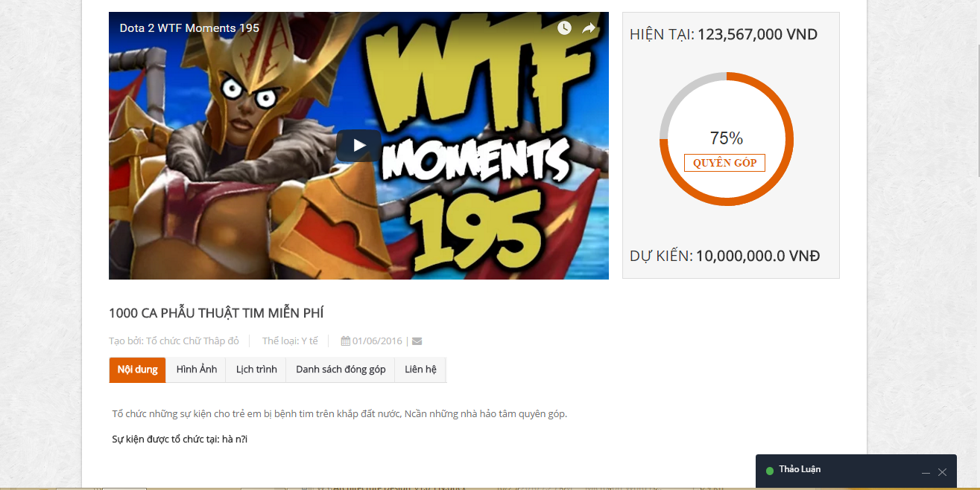

1. Event detail

|  |  |  |  |  |  |  |  |
| --- | --- | --- | --- | --- | --- | --- | --- |
| No | Field name | Field name in Vietnamese | Type | Require | Mandatory | Max-Length | Description |
| 1 | Name of Event | Tên Event | Label |  | Y |  | Name of event |
| 2 | Name of creator | Tên người gây quỹ | Label |  | Y |  | Name of creator |
| 3 | Category | Thể loại | Label |  | Y |  | Category of Event |
| 4 | Created date | Ngày tạo | Label |  | Y |  | Created date |
| 5 | Send massage | Gửi tin nhắn | Icon |  | Y |  | Send massage to organization |
| 6 | Content | Nội dung | Tab | Click | Y |  | Content of Event |
| 7 | Pictures | Hình ảnh | Tab | Click | Y |  | Pictures of Event |
| 8 | Schedule | Lịch trình | Tab | Click | Y |  | Schedule of Event |
| 9 | List of donor | Danh sách đóng góp | Tab | Click | Y |  | List of donor to event |
| 10 | Tab contact | Liên hệ | Tab | Click | Y |  | Display contact information of event |
| 12 | Donate | Đóng góp | Button | Click | Y |  | Display comment of event |
| 13 | Join in | Tham gia | Button |  |  |  | Join in event |
| 14 | Like | Thích | Button |  |  |  | Like event |
| 15 | Share | Chia sẻ | Button |  |  |  | Share event |
|  |  |  |  |  |  |  |  |

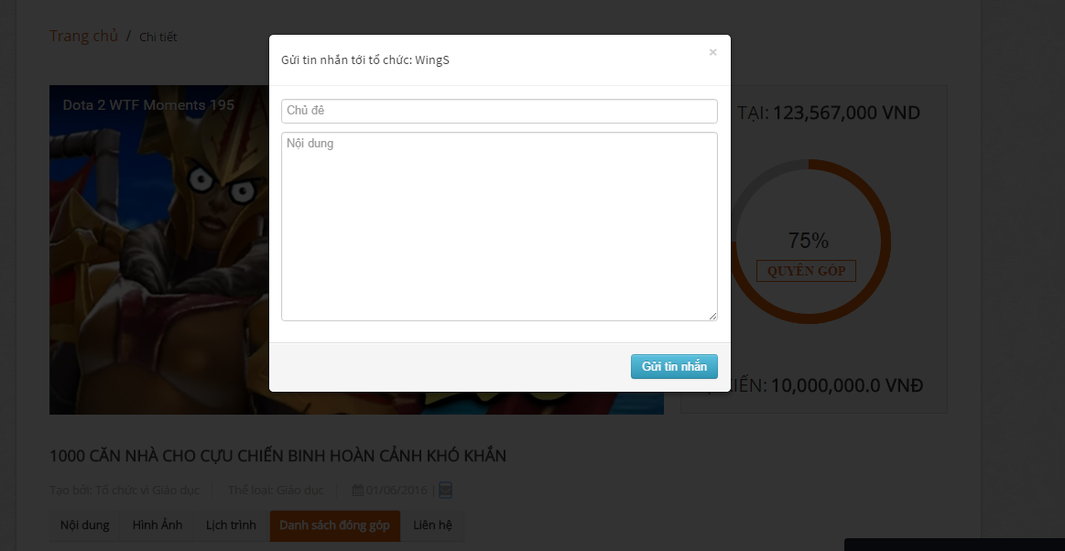

1. Sent report, question screen

|  |  |  |  |  |  |  |  |
| --- | --- | --- | --- | --- | --- | --- | --- |
| No | Field name | Field name in Vietnamese | Type | Require | Mandatory | Max-Length | Description |
| 2 | Sent a question | Gửi tin nhắn | Icon | Click | Y |  | Sent a question to creator’Event |
| 3 | Popup Sent message | Popup tin nhắn | Popup |  |  |  | Display popup sent message when click “Message” icon |
| 4 | Report this event | Báo cáo sai phạm | Button | Click | Y |  | Report Event |
| 5 | Popup Report this event | Popup Báo cáo Event | Popup |  |  |  | Display popup report event when click “Report” icon |

1. Sent report, question

### Update event

1. Update tab screen

|  |  |  |  |  |  |  |  |
| --- | --- | --- | --- | --- | --- | --- | --- |
| No | Field name | Field name in Vietnamese | Type | Require | Mandatory | Max-Length | Description |
|  |  |  |  |  |  |  |  |

1. Update tab

### Comment

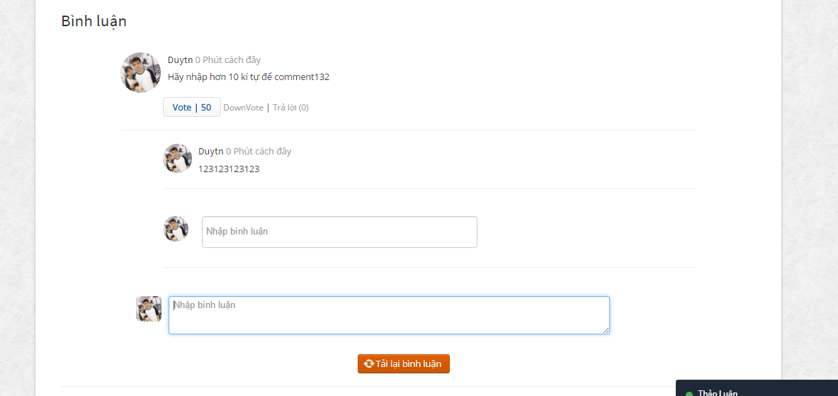

1. Comment tab screen

|  |  |  |  |  |  |  |  |  |
| --- | --- | --- | --- | --- | --- | --- | --- | --- |
| No | | Field name | Field name in Vietnamese | Type | Require | Mandatory | Max-Length | Description |
| 1 | List comments | | Bình luận | List |  | Y |  | Display list comment |
| 2 | Input comment | | Nhập bình luận… | Textarea |  | Y | 10-500 | Display content of comment. |
| 3 | Reply | | Trả lời | Button | Click | Y |  | Sent a reply to comment. |
| 5 | Refresh | | Tải lại bình luận | Button | Click |  |  | Refresh all comments. |

1. Comment tab

## Donate

### Donate

1. Back Event screen

|  |  |  |  |  |  |  |  |
| --- | --- | --- | --- | --- | --- | --- | --- |
| No | Field name | Field name in Vietnamese | Type | Require | Mandatory | Max-Length | Description |
| 1 | Name of Event | Tên sự kiện | Hyperlink | Click | Y |  | Name of Event |
| 2 | Name of creator | Tên người gây quỹ | Hyperlink | Click | Y |  | Display information of creator |
| 3 | List reward | Danh sách gói quà | Radio | Click | Y |  | Display list reward |
| 4 | Pledge | Số tiền ủng hộ | Number |  | Y |  | Pledge for Event |
| 5 | Quantity | Số lượng | Number |  | Y |  | Quantity reward |
| 6 | Continue | Tiếp tục | Button | Click | Y |  | Click to link to payment page |

1. Back Event

### Payment event

1. Payment Event screen

|  |  |  |  |  |  |  |  |  |
| --- | --- | --- | --- | --- | --- | --- | --- | --- |
| No | | Field name | Field name in Vietnamese | Type | Require | Mandatory | Max-Length | Description |
| 1 | Avatar | | Ảnh đại điện | Image |  |  |  | Display avartar |
| 2 | Full name | | Tên đầy đủ | Text |  | Y |  | Full name of backer |
| 3 | Email | | Email | Text |  | Y |  | Email of backer |
| 4 | Address | | Địa chỉ | Text |  | Y |  | Address of backer |
| 5 | Phone number | | Số điện thoại | Text |  | Y |  | Phone number of backer |
| 6 | More info | | Thông tin thêm | Textarea |  |  |  | More information about reward,… |
| 7 | Back | | Ủng hộ | Button |  | Y |  | Back Event |

1. Payment Event

## Message

### Message view

## Account management

### View Profile

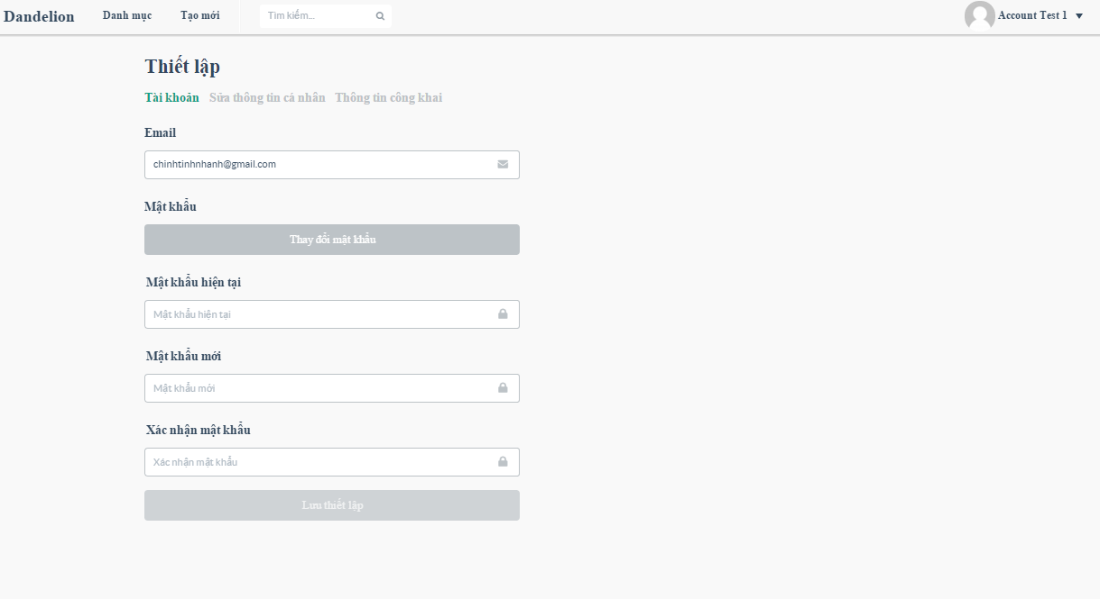

1. Account screen

|  |  |  |  |  |  |  |  |
| --- | --- | --- | --- | --- | --- | --- | --- |
| No | Field name | Field name in Vietnamese | Type | Require | Mandatory | Max-Length | Description |
| 1 | Account | Tài khoản | Hyperlink |  | Y |  | Display information account |
| 2 | Edit profile | Sửa thông tin tài khoản | Hyperlink |  | Y |  | Display edit profile |
| 3 | Public profile | Thông tin công khai | Hyperlink |  | Y |  | Display public profile |
| 4 | Email | Email | Text |  | Y |  | Email of user |
| 5 | Change Password | Thay đổi mật khẩu | Button |  | Y |  | Toogle hide/show the change password |
| 6 | Current password | Mật khẩu hiện tại | Text |  | Y |  | Current password |
| 7 | New password | Mật khẩu mới | Text |  | Y |  | New password |
| 8 | Confirm New password | Xác nhận mật khẩu | Text |  | Y |  | Confirm New password |
| 9 | Save changes | Lưu thiết lập | Button |  | Y |  | Save changes password |

1. Account

### Edit profile

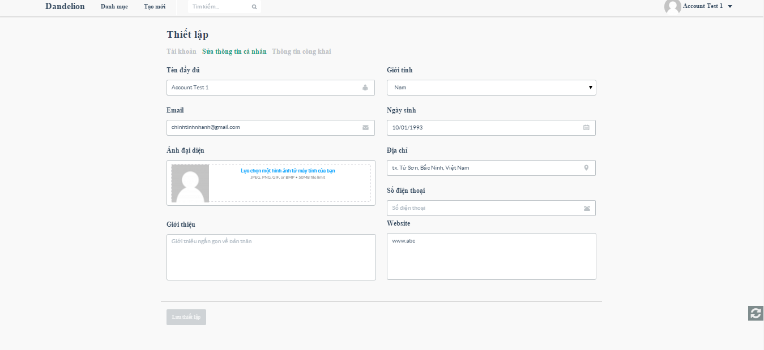

1. Edit profile screen

|  |  |  |  |  |  |  |  |
| --- | --- | --- | --- | --- | --- | --- | --- |
| No | Field name | Field name in Vietnamese | Type | Require | Mandatory | Max-Length | Description |
| 1 | Account | Tài khoản | Hyperlink |  | Y |  | Display information account |
| 2 | Edit profile | Sửa thông tin tài khoản | Hyperlink |  | Y |  | Display edit profile |
| 3 | Public profile | Thông tin công khai | Hyperlink |  | Y |  | Display public profile |
| 4 | Full name | Tên đầy đủ | Text |  | Y |  | Full name of user |
| 5 | Email | Email | Text |  | Y |  | Email of user |
| 6 | Avatar | Ảnh đại diện | Image |  |  |  | Avatar of user |
| 7 | Introduce | Giới thiêu | Textarea |  |  |  | Introduce about user |
| 8 | Gender | Giới tính | Dropdownlist |  | Y |  | Gender: Male/Female |
| 9 | Date of birth | Ngày sinh | Date |  |  |  | Date of birth of user |
| 10 | Address | Địa chỉ | Text |  |  |  | Address of user |
| 11 | Phone number | Số điện thoại | Text |  |  |  | Phone number of user |
| 12 | Website | Website | Textarea |  |  |  | Website of user, company,… |
| 13 | Save changes | Lưu thiết lập | Button |  | Y |  | Save changes |

1. Edit profile

## ADMIN

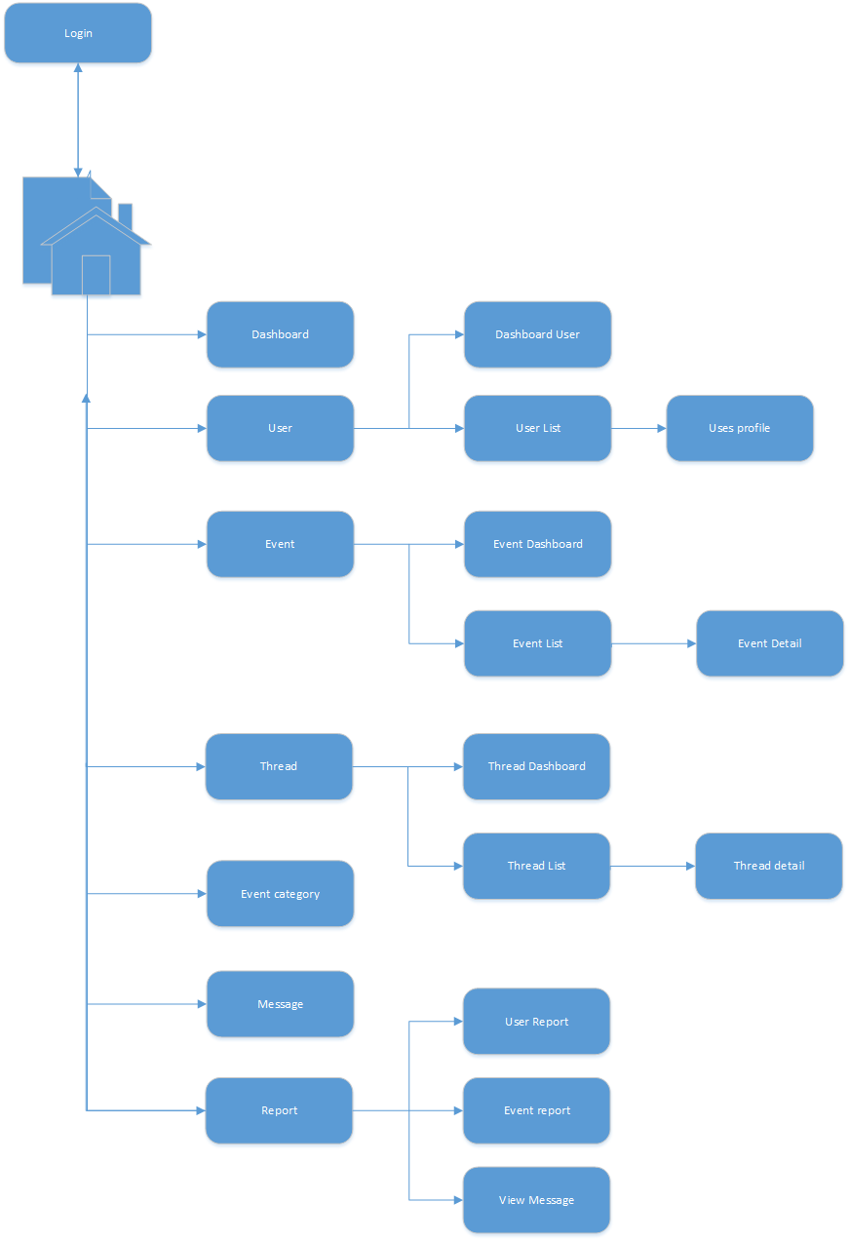

1. Admin screen flow

### Login

1. Login screen

|  |  |  |  |  |  |  |  |
| --- | --- | --- | --- | --- | --- | --- | --- |
| No | Field name | Field name in Vietnamese | Type | Require | Mandatory | Max-Length | Description |
| 1 | Username or email | Tên tài khoản hoặc email | Text box | Type | Y |  | Username or Email of Admin |
| 2 | Password | Mật khẩu | Text box | Type | Y |  | Password of registered Admin |
| 3 | Remember Me | Lưu đăng nhập | Check box | Click | Y |  | Save login information |
| 4 | Login | Đăng nhập | Button | Click | Y |  | Login |

1. Login

### Dashboard

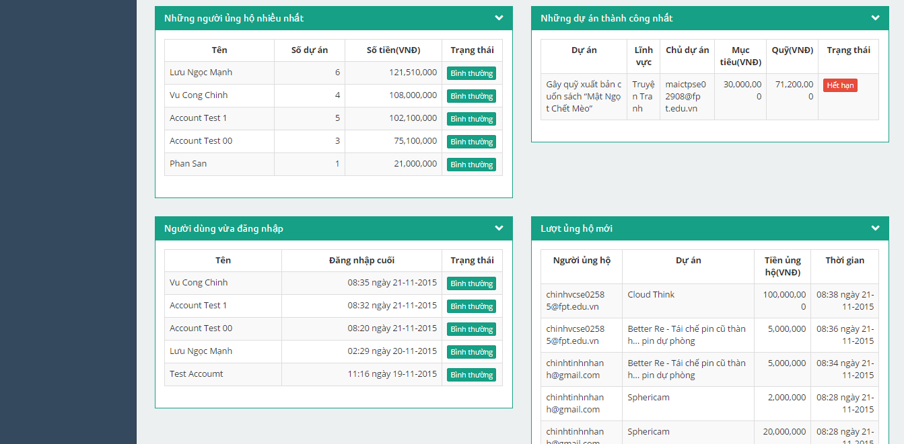

1. Dash board 2

|  |  |  |  |  |  |  |  |
| --- | --- | --- | --- | --- | --- | --- | --- |
| No | Field name | Field name in Vietnamese | Type | Require | Mandatory | Max-Length | Description |
| 1 | Total users | Số người dùng | Label |  | Y |  | Total users registed |
| 2 | Total Event | Số sự kiện | Label |  | Y |  | Total Event is created |
| 3 | Total back | Số tiền được ủng hộ | Label |  | Y |  | Total money is back |
| 4 | Profit | Lợi nhuận | Label |  | Y |  | Profit from Events success |
| 5 | Total Event pending | Số sự kiện chờ duyệt | Label |  | Y |  | Total Event is pending |
| 6 | Total Event running | Số sự kiện đang chạy | Label |  | Y |  | Total Event is running |
| 7 | Category pie chart | Lĩnh vực | Chart |  | Y |  | Chart display percent of item in categories |
| 8 | Rank pie chart | Hạng sự kiện | Chart |  | Y |  | Chart display percent, number Event in Rank (A,B,C,D) |
| 9 | Rate success/fail pie chart | Tỷ lệ thành công | Chart |  | Y |  | Chart display percent, number Event success, fail |
| 10 | Top backer | Người ủng hộ nhiều nhất | Table |  | Y |  | Table top 5 backer |
| 11 | Top success Event | Sự kiện thành công nhất | Table |  | Y |  | Table top 5 Event success |
| 12 | Top recent login | Người dùng vừa đăng nhập | Table |  | Y |  | Table top 5 user recent login |
| 13 | Top recent back | Lượt ủng hộ mới | Table |  | Y |  | Table top 5 recent back |
| 14 | Statistic Event by Year | Biểu đồ thống kê sự kiện theo năm | Chart |  | Y |  | Chart Statistic Event by Year |
| 15 | Statistic Event | Biểu đồ thống kê sự kiện | Table |  | Y |  | Table Statistic Event by Year |

1. Dashboard

### Users

#### Users dashboard

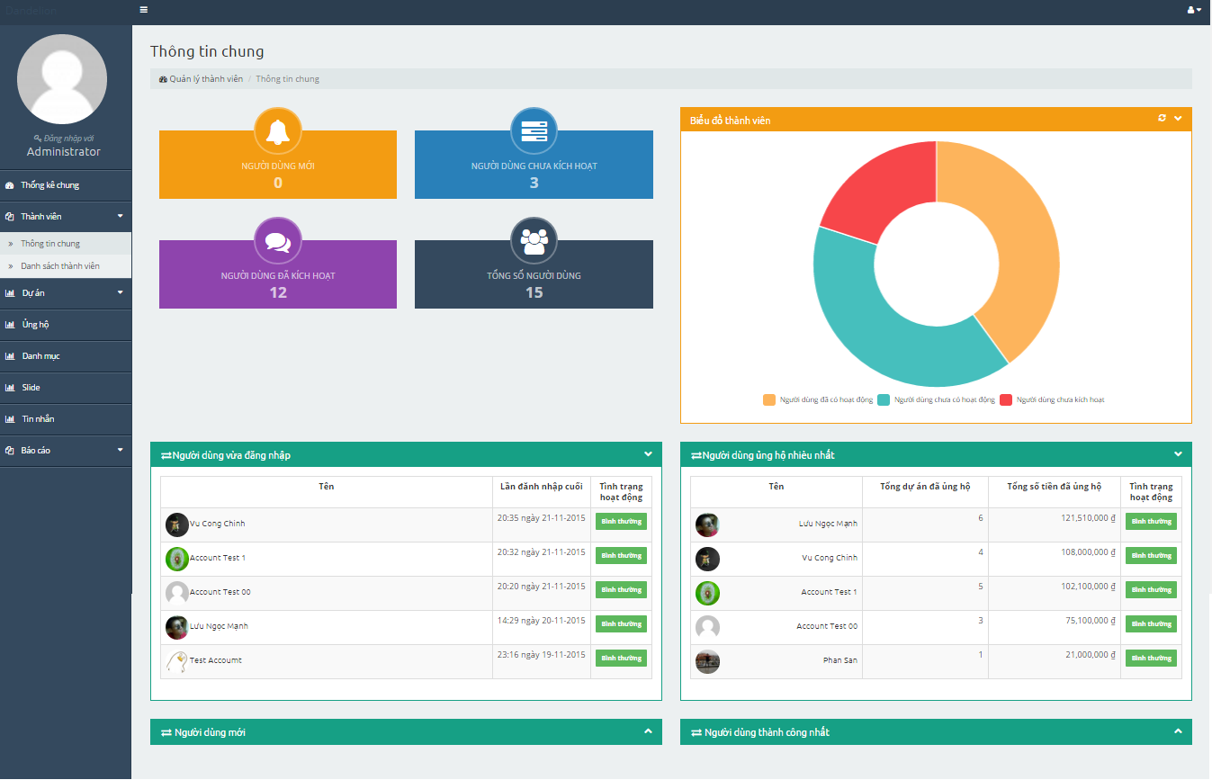

1. Users dashboard screen

|  |  |  |  |  |  |  |  |
| --- | --- | --- | --- | --- | --- | --- | --- |
| No | Field name | Field name in Vietnamese | Type | Require | Mandatory | Max-Length | Description |
| 1 | Total users | Tổng số người dùng | Label |  | Y |  | Total users registed |
| 2 | Total new users | Người dùng mới | Label |  | Y |  | Total new users |
| 3 | Total users deactive | Người dùng chưa kích hoạt | Label |  | Y |  | Total user NOT Active |
| 4 | Total users active | Người dùng đã kích hoạt | Label |  | Y |  | Total user Active |
| 5 | Member chart | Biểu đồ thành viên | Chart |  | Y |  | Member chart |
| 6 | User recent loged in | Người dùng vừa đăng nhập | Table |  | Y |  | User recent loged in |
| 7 | Most user backed | Người dùng ủng hộ nhiều nhất | Table |  | Y |  | Most user backed |
| 8 | New users | Người dùng mới | Table |  | Y |  | New users |
| 9 | Most success users | Người dùng thành công nhất | Table |  | Y |  | Most success users |
| 10 | Avatar | Ảnh đại diện | Button | Click | Y |  | Click on avatar of user in table will link to profile of user |

1. Users dashboard

#### Users list

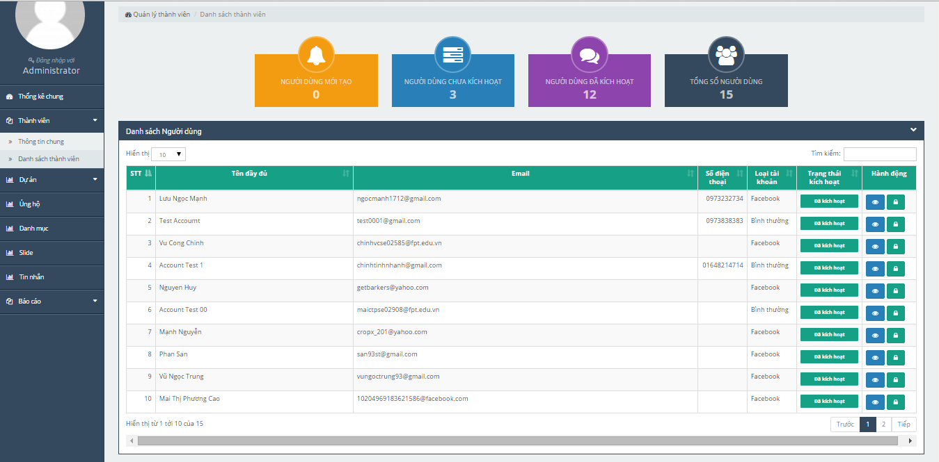

1. Users list screen

|  |  |  |  |  |  |  |  |
| --- | --- | --- | --- | --- | --- | --- | --- |
| No | Field name | Field name in Vietnamese | Type | Require | Mandatory | Max-Length | Description |
| 1 | Total users | Tổng số người dùng | Label |  | Y |  | Total users registed |
| 2 | Total new users | Người dùng mới | Label |  | Y |  | Total new users |
| 3 | Total users deactive | Người dùng chưa kích hoạt | Label |  | Y |  | Total user NOT Active |
| 4 | Total users active | Người dùng đã kích hoạt | Label |  | Y |  | Total user Active |
| 5 | List users | Danh sách người dùng | Table |  | Y |  | List users |
| 6 | View (icon) | Xem (biểu tượng) | Button | Click | Y |  | Link to profile of user |
| 7 | Active (icon) | Mở khóa (biểu tượng) | Button | Click | Y |  | Unlock/Active user |
| 8 | Deactive (icon) | Khóa (biểu tượng) | Button | Click | Y |  | Lock/Deactive user |

1. Users list
2. User’profile screen

### Event

#### Event dashboard

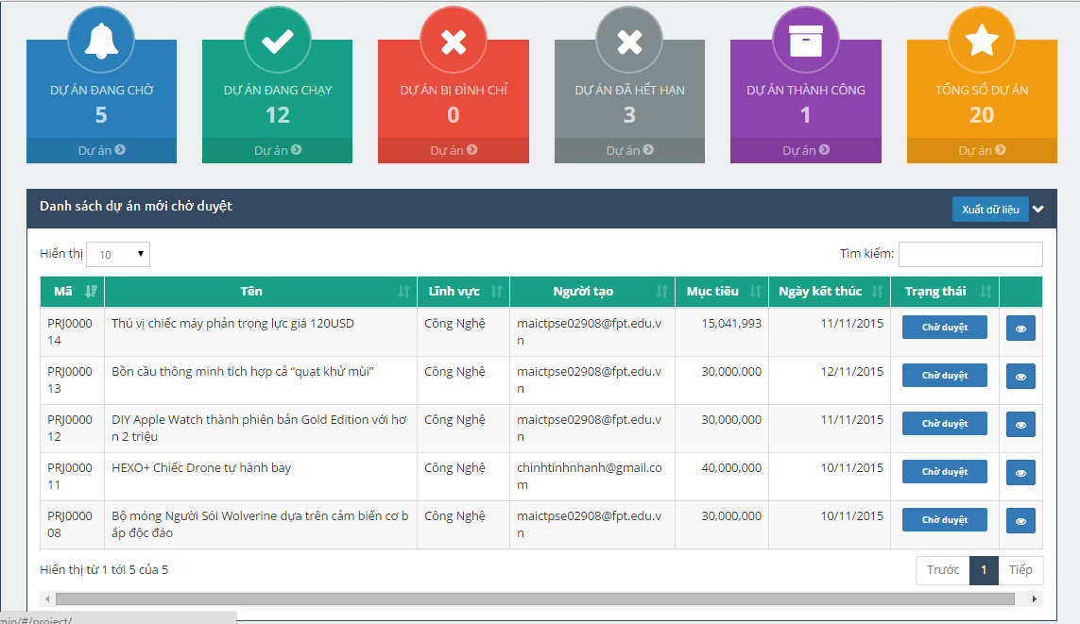

1. Event dashboard screen

|  |  |  |  |  |  |  |  |
| --- | --- | --- | --- | --- | --- | --- | --- |
| No | Field name | Field name in Vietnamese | Type | Require | Mandatory | Max-Length | Description |
| 1 | Total Event pending | Số sự kiện đang chờ | Label |  | Y |  | Total Event pending |
| 2 | Total Event running | Số sự kiện đang chạy | Label |  | Y |  | Total Event running |
| 3 | Total Event postpone | Số sự kiện đình chỉ | Label |  | Y |  | Total Event postpone |
| 4 | Total Event endate | Số sự kiện hết hạn | Label |  | Y |  | Total Event endate |
| 5 | Total Event success | Số sự kiện thành công | Label |  | Y |  | Total Event success |
| 6 | Total Event | Tống số sự kiện | Label |  | Y |  | Total Event |
| 7 | List Events | Danh sách sự kiện mới chờ duyệt | Table |  | Y |  | List Events |
| 8 | View (icon) | Xem (biểu tượng) | Button | Click | Y |  | Link to Event details |

1. Event dashboard

#### Events list

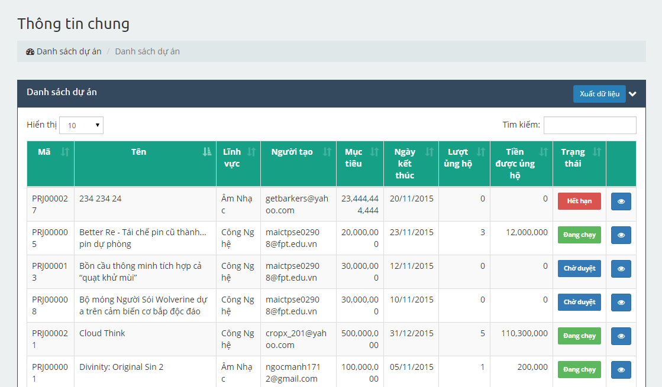

1. Events list screen

|  |  |  |  |  |  |  |  |
| --- | --- | --- | --- | --- | --- | --- | --- |
| No | Field name | Field name in Vietnamese | Type | Require | Mandatory | Max-Length | Description |
| 1 | List Events | Danh sách sự kiện mới chờ duyệt | Table |  | Y |  | List Events |
| 2 | View (icon) | Xem (biểu tượng) | Button | Click | Y |  | Link to Event details |

1. Event list

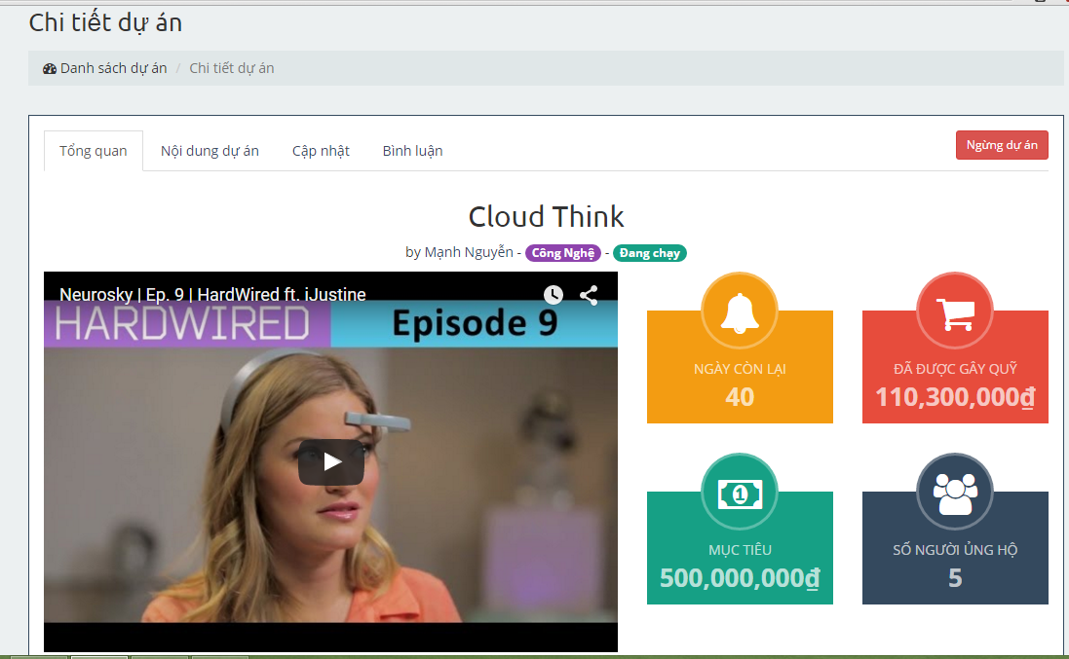

1. Event detail screen

|  |  |  |  |  |  |  |  |
| --- | --- | --- | --- | --- | --- | --- | --- |
| No | Field name | Field name in Vietnamese | Type | Require | Mandatory | Max-Length | Description |
| 1 | Infomation | Tổng quan | Tab |  | Y |  | Profile |
| 2 | Backed Event | Nội dung sự kiện | Tab |  | Y |  | Backed Event |
| 3 | Created Event | Cập nhật | Tab |  | Y |  | Created Event |
| 4 | Comment | Bình luận | Tab |  | Y |  | Comment |
| 5 | Accept | Chập nhận | Button |  | Y |  | Accept to Event running |
| 6 | Reject | Từ chối | Button |  | Y |  | Reject Event |
| 7 | Postpone | Ngừng sự kiện | Button |  | Y |  | Postpoen Event |

1. Event detail

### Donate

### Category

### Message

### Report

#### Report user

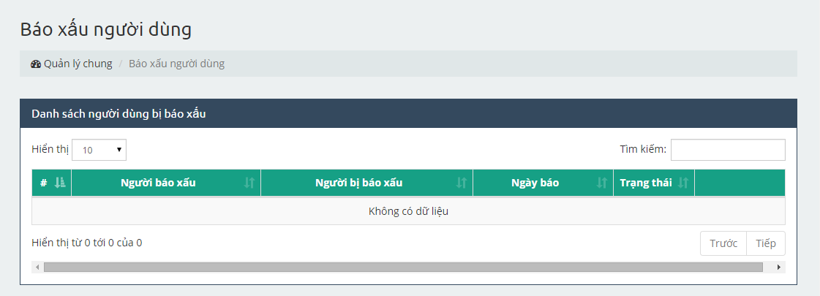

1. Report user management screen

|  |  |  |  |  |  |  |  |
| --- | --- | --- | --- | --- | --- | --- | --- |
| No | Field name | Field name in Vietnamese | Type | Require | Mandatory | Max-Length | Description |
| 1 | List report user | Danh sách người dùng bị báo xấu | Table |  | Y |  | List report user |
| 2 | View (icon) | Xem (biểu tượng) | Button | Click | Y |  | View content of the report |
| 3 | Accept (icon) | Đồng ý (biểu tượng) | Button | Click | Y |  | Accept with the report |
| 4 | Cancel (icon) | Hủy (biểu tượng) | Button | Click | Y |  | Cancel with the report |

1. Report user management

#### Report Event

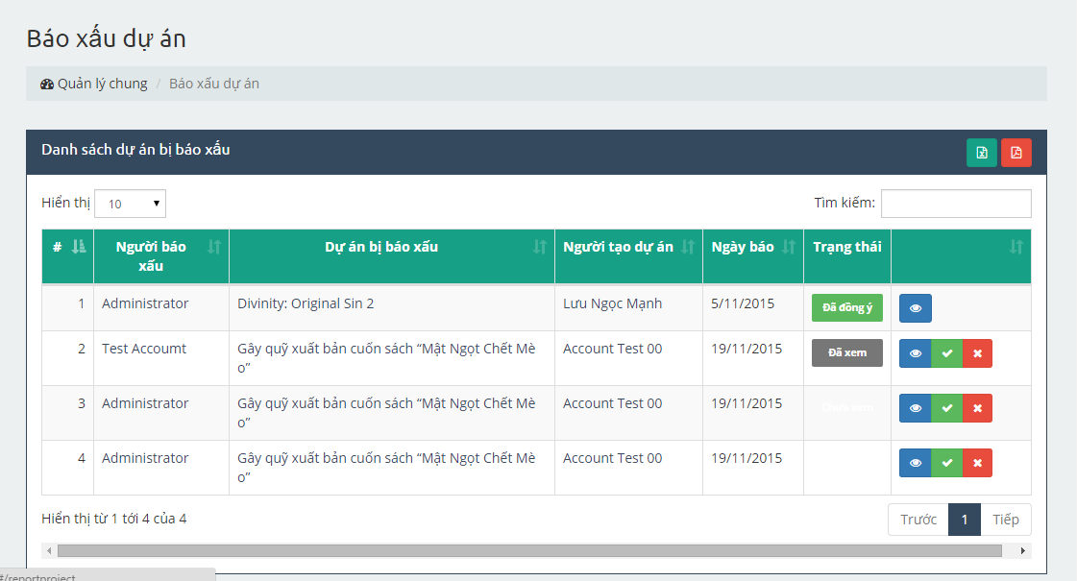

1. Report Event management screen

|  |  |  |  |  |  |  |  |
| --- | --- | --- | --- | --- | --- | --- | --- |
| No | Field name | Field name in Vietnamese | Type | Require | Mandatory | Max-Length | Description |
| 1 | List report Event | Danh sách người dùng bị báo xấu | Table |  | Y |  | List report Event |
| 2 | View (icon) | Xem (biểu tượng) | Button | Click | Y |  | View content of the report |
| 3 | Accept (icon) | Đồng ý (biểu tượng) | Button | Click | Y |  | Accept with the report |
| 4 | Cancel (icon) | Hủy (biểu tượng) | Button | Click | Y |  | Cancel with the report |

1. Report Event management